**OPEN EMR, HIS & QUEUING SYSTEM**

**STEP 1. QMS**

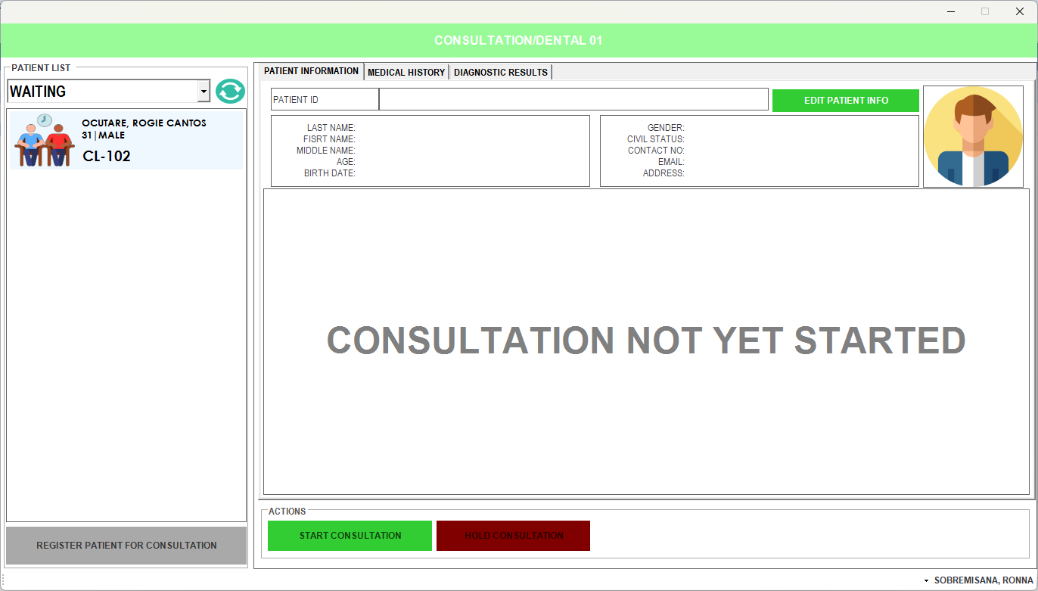**SELECT THE PATIENT ON QUEUE THEN CLICK START CONSULTATION. THE PATIENT WILL HAND YOU A TICKET WITH THEIR NAME TO CONFIRM.**

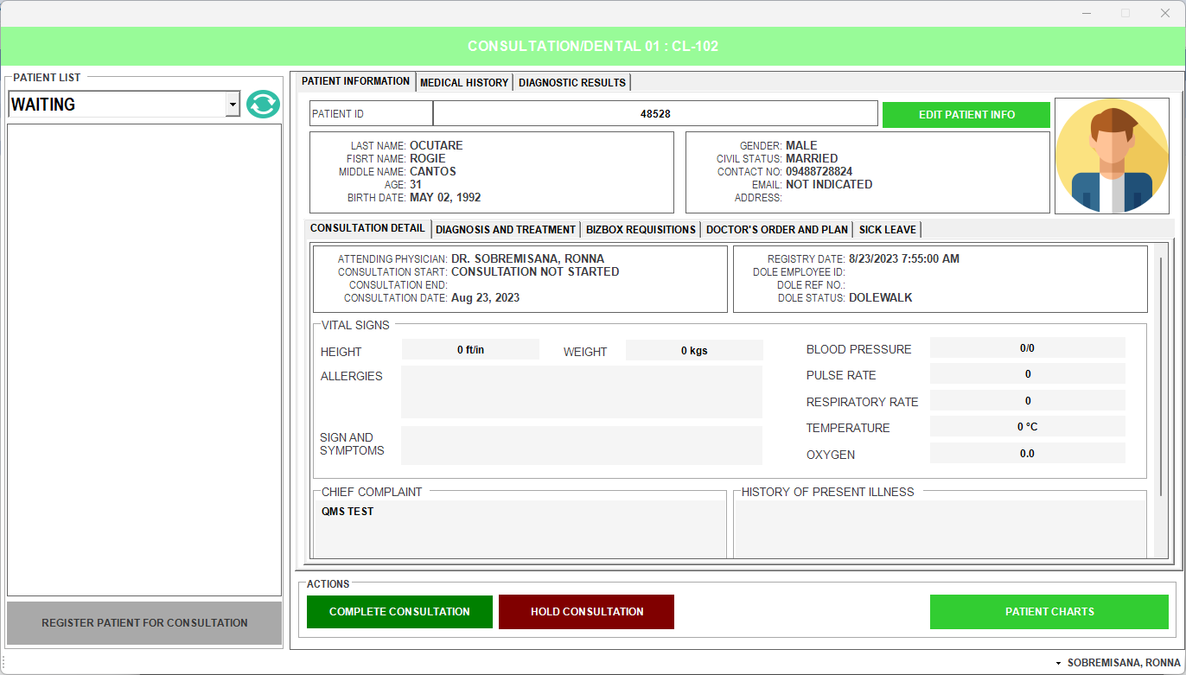**PATIENT DETAILS WILL APPEAR**

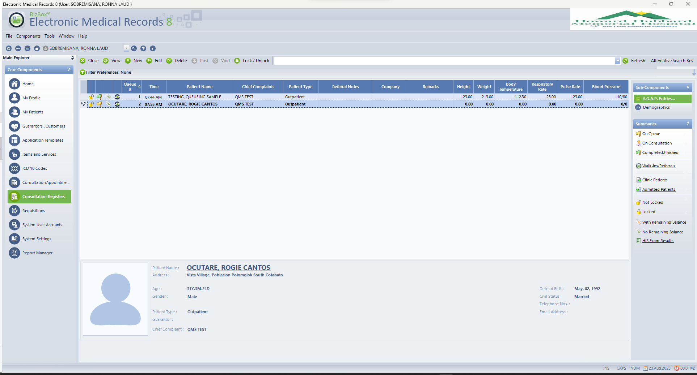**GO TO ELECTRIC MEDICAL RECORDS (EMR)**

**CLICK S.O.A.P. ENTRIES**

**FILL UP NECESSARY DETAILS OF THE PATIENT AND DATE OF SICKLEAVE.**

**THEN CLICK SAVE AND CLOSE.**

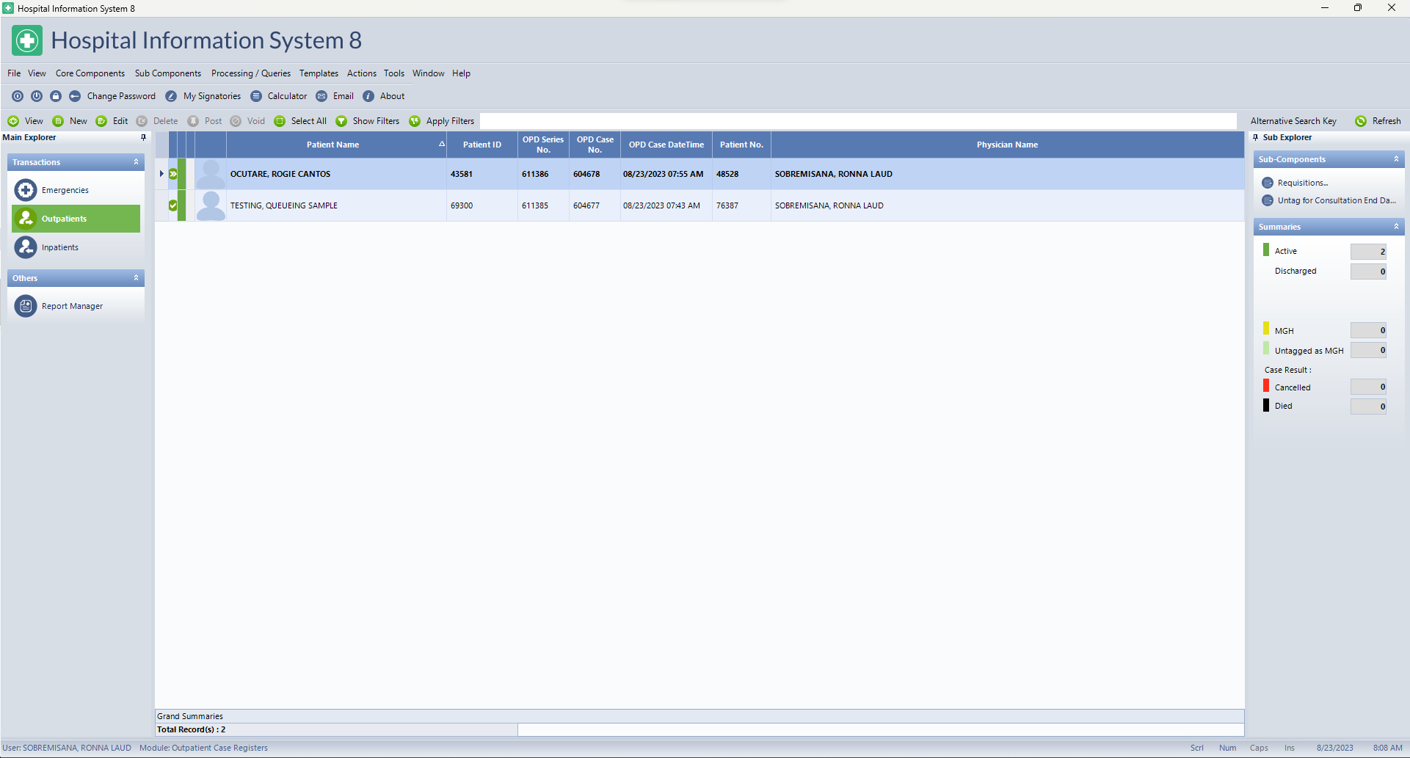**OPEN HIS THEN CLICK OUTPATIENTS**

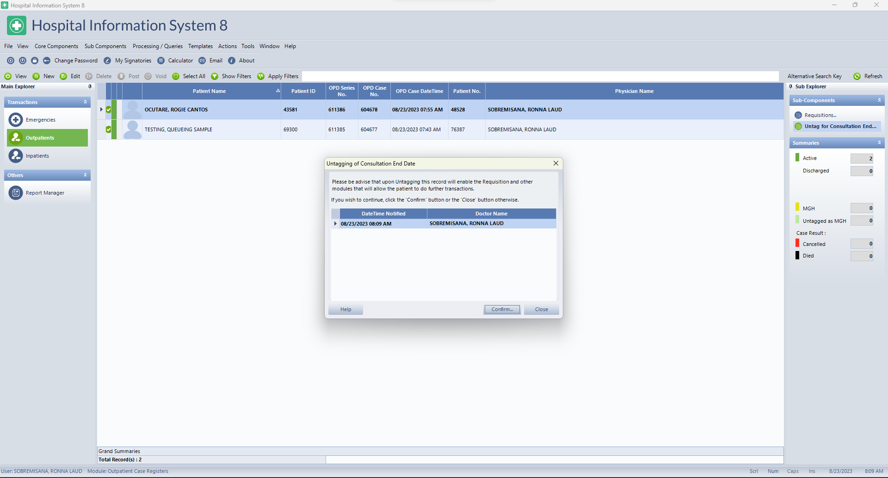**FIND THE PATIENT THEN CLICK UNTAG FOR CONSULTATION, THEN CLICK CONFIRM**

**CLICK REQUISITIONS**



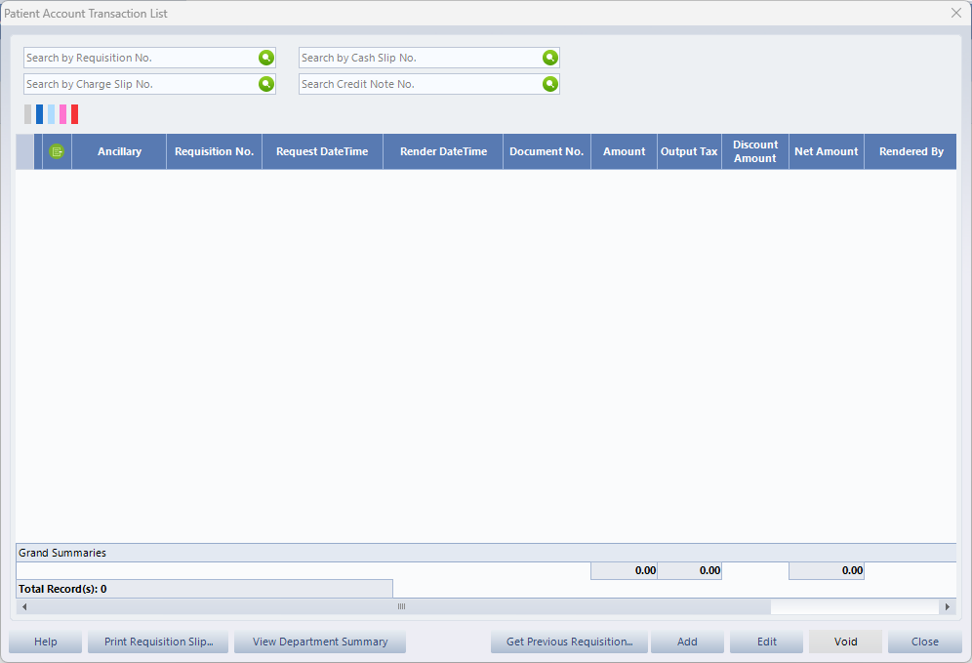**CLICK ADD**

**LISTED ARE THE DEPARTMENTS CLICK THE SPECIFIC DEPARTEMENT FOR YOUR REQUEST.**

**PHARMACY - MEDICINES**

**LABORATORY AND RADIOLOGY - DIAGNOSTICS**

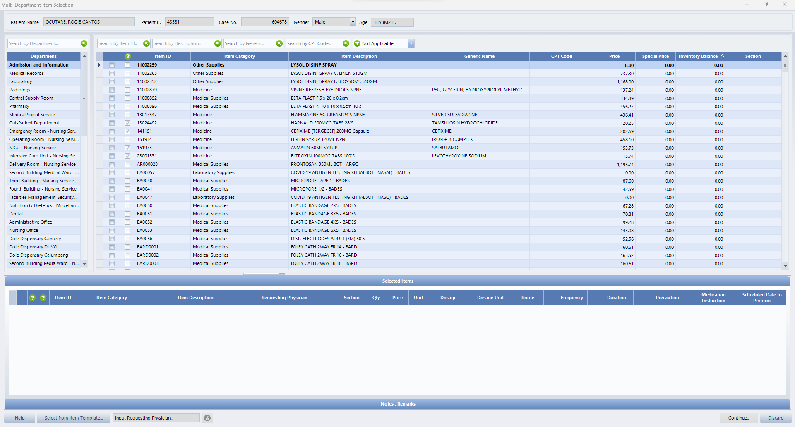

**AFTER REQUEST THIS WILL BE THE APPEARANCE**

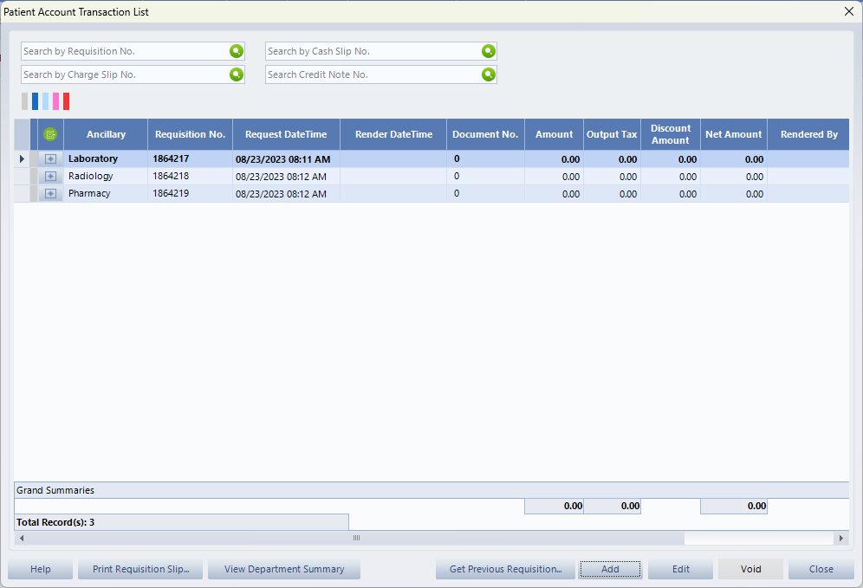

**THEN RETURN TO QMS**

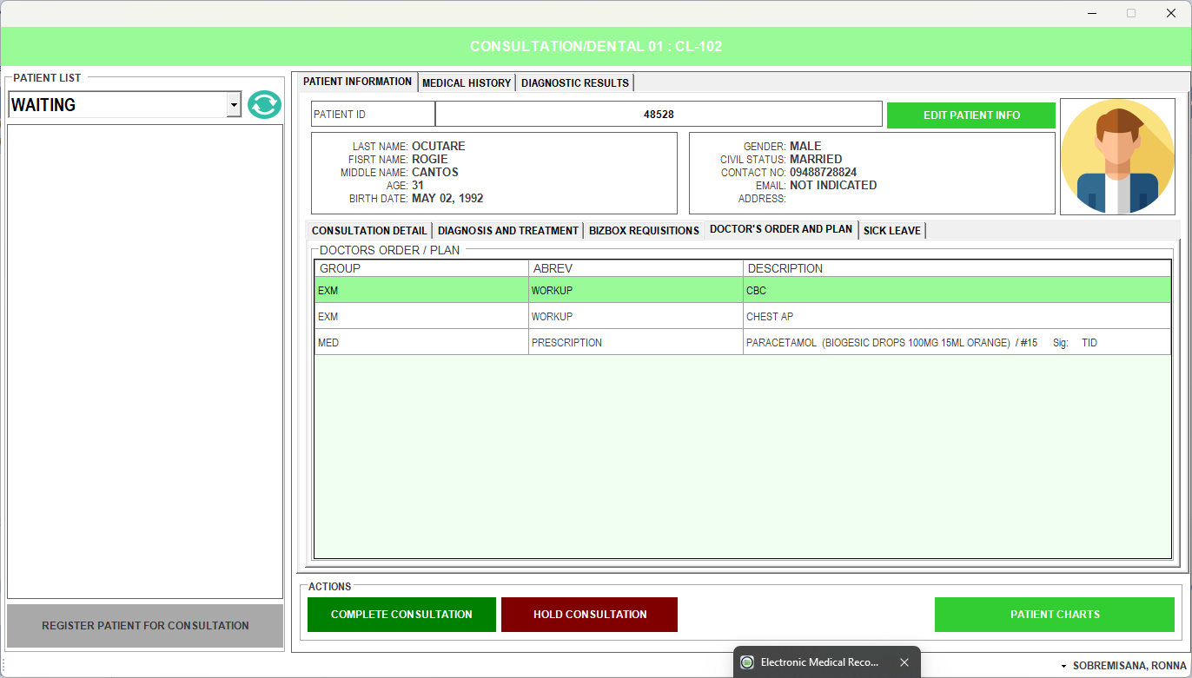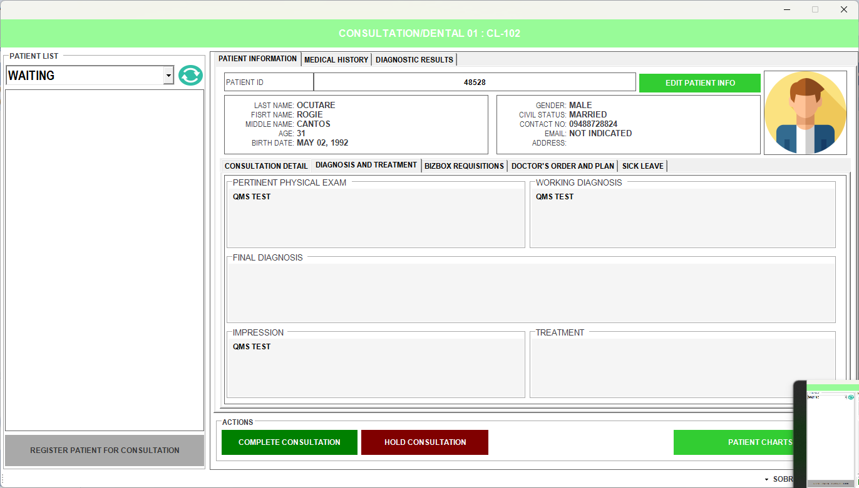**ALL YOUR INPUTS IN EMR & HIS WILL APPEAR IN QMS**

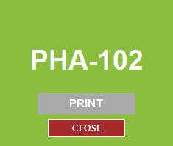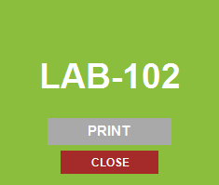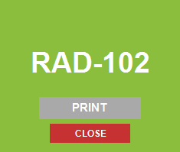**THEN CLICK COMPLETE CONSULTATION, EVERY DEPARTMENT REQUESTED A NUMBER WILL APPEAR, PLEASE WRITE IT AT THE BACK OF THE TICKET OF THE PATIENT.**